 

***Vibrations in Upper Atlas***

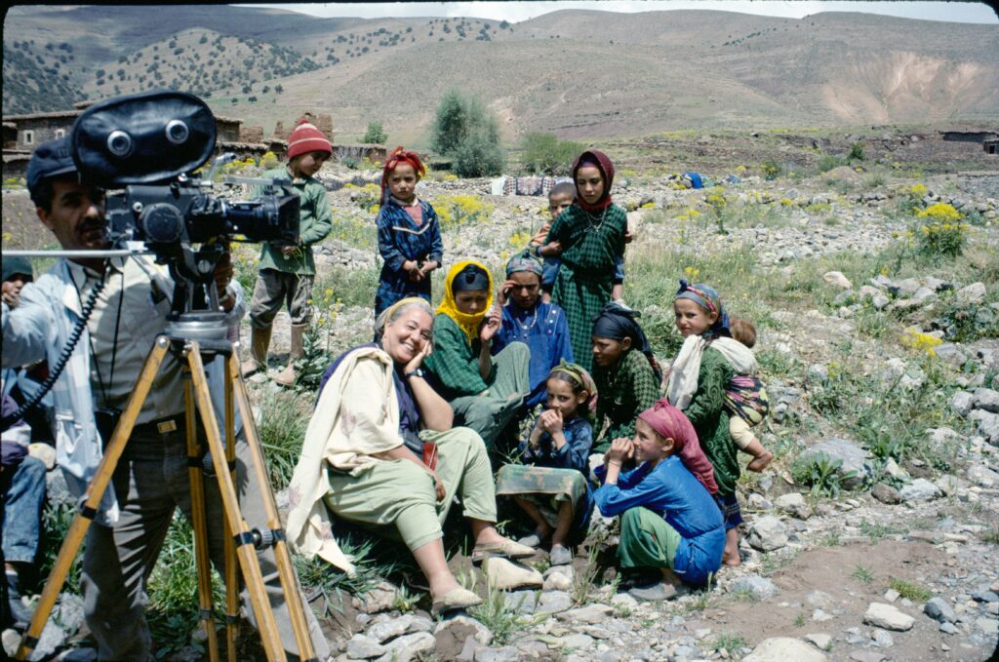

**Director:** Izza Genini

**Type:** Documentary

**Origin:** Morocco

**Year:** 1993

**Screening time:** 27 min

**Director Biography:** Izza Génini (1942, Casablanca) is a self-taught French-Moroccan-Amazigh film director and producer based in Paris. In the 1980s, Génini founded the distribution company SOGEVAL, producing and distributing some of the first Moroccan and African music films. She then shot more than 20 documentary films, capturing and preserving the rich and diverse culture of Moroccan Amazigh people. Her influential films highlight the connections between nature, people, and cultural expression, often centering on women artists, Amazigh Jewish and diasporic identity, and the wide variety of socio-cultural contexts of music in Morocco. For more insight into Genini’s development as a filmmaker, see Stephanie Van der Peer’s 2017 [article](https://drive.google.com/file/d/1BX8dYXl0AWr14IZlDFuGrx0Ww9jVsB5k/view?usp=sharing).

**Synopsis:** “Vibrations in Upper Atlas” documents a journey to Ait Bouguemez Valley as it strips away modernity and immerses humans in nature. Water and music are central to shaping life's rituals. Women's songs echo through polyphonies, ululations, and refrains, accompanying every endeavor, embodying the ancient cosmos.

**Background:** “Amazigh” is the singular of “Imazighen” which means “free people.” Formerly known by the pejorative term “Berbers,” these ethnically diverse people are the native or indigenous inhabitants of North, Sahelian, and Sub-Saharan Africa. Located in several countries and grouped into numerous communities, including the Kabyle, Tuareg, Chleuhs, and Siwis, they are majority Muslim and share common cultural practices including their language, Tamazight, written with the Tifinagh alphabet. In the 20th c., the movement of Amazigh people to Europe and the US formed an international diaspora. Today, the Amazigh are known for their contributions to world music, artisan crafts, and transnational film.

**KEY INSIGHTS OF AMAZIGH CINEMA**

* Since the [mid-1990s](https://muse.jhu.edu/article/728425/pdf), Amazigh artists have produced videos, shorts, documentaries, and fictional films to represent the challenges and resiliency of Amazigh identities in changing times and in relation to Arab, European, and North American cultures. The stories they tell bridge locations and mentalities - village and city, nation and diaspora - and use multiple languages including their native Tamazight.
* No one film captures Amazigh identity or life – only a wide variety of films and videos can offer viewers a grounded sense of contemporary issues and values impacting these diverse communities.
* Film is one way to understand and preserve an ancient culture in active transformation

***VIBRATIONS IN THE UPPER ATLAS***

**FILM THEMES**

1. Nature and Indigenous Identity
2. Music as a source of Ecological Knowledge
3. Women and the Environment

**FILM ASSIGNMENT**

*Prior reflections:*

* What do you know about indigenous culture and its relationship to the natural world?
* How does indigenous culture contribute to the protection of the environment?
* Did you hear about the High Atlas earthquake in Morocco in 2023? What might an event like an earthquake tell you about the region’s history and culture? Read Bahri’s (2023) [article](https://drive.google.com/file/d/1k6lTzYzYbwC3CU1PagDflLvCHCiY1pHC/view?usp=sharing) from pages 4-6 for hints.
* Are you familiar with folk dancing and singing? How do they differ from mainstream styles of dancing and singing?

*Making observations:*

1. Describe in a sentence or two what you expected when you read the title of the documentary.
2. The opening scenes of the documentary are accompanied by a soundtrack of women’s voices singing. The women appear later on in the film singing in the same manner. How would you describe this kind of singing?
3. Based on the documentary and using what you know about indigenous culture, describe how music and singing are interconnected with the daily life of the High Atlas community. How might the music connect to the “memory and resilience” theme?
4. Several of the women’s activities in the documentary are centered on the forest, land, and water. Name some of those activities shown in the documentary. How might those activities help conserve the environment and or strengthen gender equity?
5. The celebration in the valley consists of a typical form of dancing while singing. Describe the choreographic elements and musical instruments involved in the performance of this dance. Describe gender roles in this dance.
6. Observe the camera movement throughout the documentary. Do you feel the camera is an insider or outsider? Why and what might be the filmmaker’s intention?

*Analysis - choose one:*

1. Women’s singing, conservation activities, and nature are three elements that mark the daily life of the High Atlas Valley. How is the interconnectivity between the three elements presented in the film? What type of identity is revealed or built through the interrelation of the three elements?
2. The relationship between High Atlas inhabitants and their environment reveals their vulnerability to natural disasters, such as climate change and earthquakes. Based on the documentary and Chtatou’s (2023) [article](https://www.washingtoninstitute.org/pdf/view/18376/en), what contributes to the Amazigh people’s vulnerability to natural disasters? Do you think there are ways to integrate High Atlas culture as part of the solution to tackle natural disasters?

**CONNECTIONS:**

1. How do you incorporate nature into your daily life and routine?
2. Can you think of a poem, song, or dance that connects you to the natural, wild, or non-human world? What is it about?
3. Music, women’s singing, and dance are the elements that Izza Genin used to document her connection to her homeland heritage. If you were to document the story or history of your family or community, which elements would you focus on? Why?

**ADDITIONAL SOURCES:**

[*Who Are the Amazigh?*](https://www.youtube.com/watch?v=Swh8898LBps&feature=youtu.be) *(TRT World)*

Brahim El Guabli, “[My Amazighitude: On the Indigenous Identity of North Africa](https://themarkaz.org/my-amazighitude-on-the-indigenous-identity-of-north-africa/)” The Markaz Review, June 2022.

Rachik, Hassan. "[Berbers.](https://archive.org/details/2016-rachik-hassan-berbers-ency.-of-islam-and-the-muslim-world/page/n1/mode/2up)" *Encyclopedia of Islam and the Muslim World*, edited by Richard C. Martin, 2nd ed., vol. 1, Gale, 2016, pp. 165-167. Gale eBooks.

McNair & Laayouni, “[Amazigh Cinema and the New York Forum of Amazigh Film](https://www.jadaliyya.com/Details/43443/Amazigh-Cinema-and-the-New-York-Forum-of-Amazigh-Film-NYFAF)” *Jadaliyya, 2021.*

***Things you can do to promote intercultural understanding***

**Think** about how your culture informs your behavior and expectations when it comes to relationships and actions. **Reflect** on the way you treat people of different cultural identities. **Question** how your cultural upbringing influences your awareness of diverse identities.